Macintosh HD:Users:katielam:Desktop:logo.gif **Hong Kong Institute of Vocational Education**

**ITP4506 Human Computer Interaction and GUI Programming**

**E-commerce Website**

|  |  |  |  |
| --- | --- | --- | --- |
| **Student ID** | **Name** | **Contribution** | **Signature** |
| 160450066 | LamKitYu | 50% |  |
| 160548082 | YauTsunSing | 50% |  |

Table of Contents

1. Background 1

2. User Analysis 2

2.1. User characteristics 2

2.1.1. Learning style 2

2.1.2. Tool preferences 2

2.1.3. Physical differences 3

2.1.4. Cultural differences 3

2.1.5. Knowledge of job 3

2.1.6. Application familiarity 3

2.1.7. Primary and secondary users 3

3. Web Concept 4

3.1. User Interface design 4

3.1.1. Home Page 4

3.1.2. Hotel page 5

3.1.3. Flight page 6

3.1.4. Register/Login Page 7

3.1.5. Shopping cart Page 8

3.1.6. Payment Page 9

# Background

The Happy Travel Ltd is a medium-sized travel agent. This company want to build a website for the tertiary student in Hong Kong. First, the website user interface should be user-friendly. Also, the website should be provide the search function for user searching the items. Moreover, it should be offer the

# User Analysis

## User characteristics

### Learning style

The website is target on the student so the user have a high learning skills to use the website. The users’ habits of learning are Read-then-do. The student will go to website first, they will see what is the information will show on the website. After they read the website, they can easy to use it. The user enter the website, they will see the photo 1. They enter this website because the want to search or buy the flight ticket or book the hotel. They can click the item on the top menu. It design can let the user easily to read the first page content.

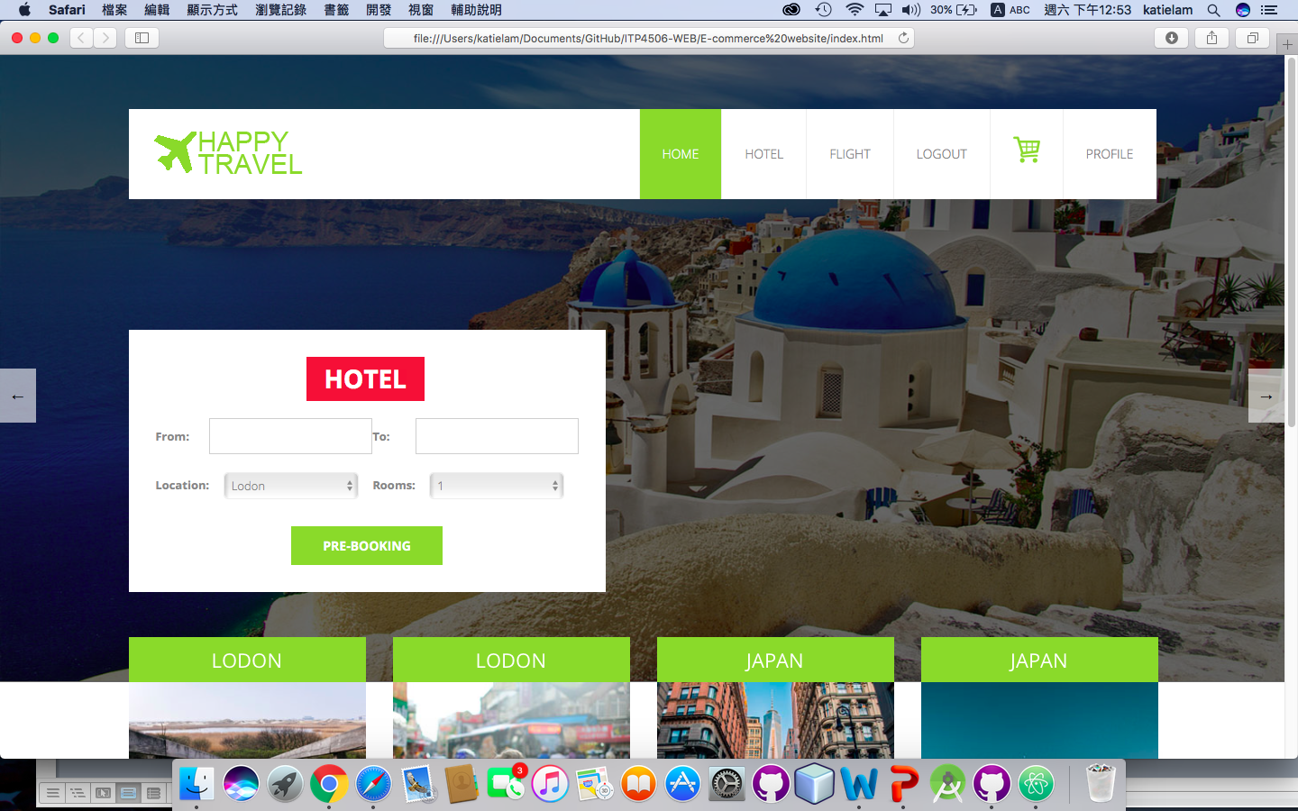(Photo 1)

### Tool preferences

The website will provide the search engines, menu and slide show. For the search engines, the website is used the flexible box to include the search item. The user can select the date from the date picker, location, number of room and number of people are also is drop-down menu. When they click the input box, it will pop up the drop down menu or date picker. It is no need to enter the information. The user chooses it only. For the menu, the website is clearly to set the name of the menu. Also, the shopping cart uses a cart logo to present it. Using photo can easy to show the meaning. For the slideshow, the slideshow both side have a button of changing. That can show to user the slide have another information.

### Physical differences

Abilities among different people may be different but this website is target on the tertiary student. So the age is around 18-30. Also, the target group has men and female. However, Considering of the vision limitations such as color blindness so the website would be set the color of green, white and grey of main color. The font sizes are not too large and too small. The title set to 18px. The content may set 14-16px.

|  |  |
| --- | --- |
| Font sizes (Title) | 18px |
| Font sizes (content) | 14-16px |
| Main color of website | Green, white and grey |

### 2.1.4. Cultural differences

The target customer is the tertiary student so they have a higher education level. Also, the reading level is also higher. For the website using specialized vocabularies, the user also can understand the meaning and they no need to check the dictionary. The website language could use English.

### Knowledge of job

For the travel agent is using specialized vocabularies. For example, customer service, booking, flight, hotel, deals, available, main amenities etc.

### Application familiarity

For the novice, they need to a guideline to follow the step-by-step using the website.

About the Expert, they no need a guideline to follow the step-by-step using the website. They can learn

### Primary and secondary users

|  |  |
| --- | --- |
| Primary User | Secondary User |
| Hotel reservation clerk | Customer who called the support line |
| Flight reservation clerk | Tertiary student |
| Travel agent |  |

## 2.2. Techniques for observing and listening to users

## 2.2.1. Think aloud

Ask the user what they want in this website. Doing the website before, we should do a search and questionnaire to collect the requirements. Listening to users think and plan, it will be able to examine their expectations for the website. Also, Listening to users as they work could provide enormous amount of useful information about develop the website.

### 2.2.2. Talk right after

After collected the information or feedback, we should discuss which comment or suggest it quite good. After the decision, we should talk about the work is it effective or easy to do.

### 2.2.3. Role-playing

Flight reservation clerk and hotel reservation clerk are no way to observe. So we need to play the role of these users in that situation.

### 2.2.4. Cueing recall with videotape

We should mark the requirements after the decision that can remind us to the website what should we have. The records should be having the user explain what was going on.

### 2.2.5. Focus groups

Regarding some students are less willing to express opinions in the public, we can do an online observation. About a group of people are asked about their perceptions, opinions, beliefs, and attitudes towards a product or service, we can search another travel agent website for our reference. It can collect some ideas for the new website for student.

### 2.2.6. Mailed/Online surveys

We would like to do an online survey because this is inexpensive. Also, in this century, the student also use the computer and mobile

## 2.3. Environment Analysis

## 2.4. Recruiting Users

## 2.5. Task Analysis (HTA)

# Web Concept

## 3.1. User Interface design

|  |  |
| --- | --- |
| Design Principles | Description |
| Mental Model |  |
| Affordance |  |
| Content Organization |  |
| Visual Organization |  |
| Navigation |  |

### 3.1.1. Home Page



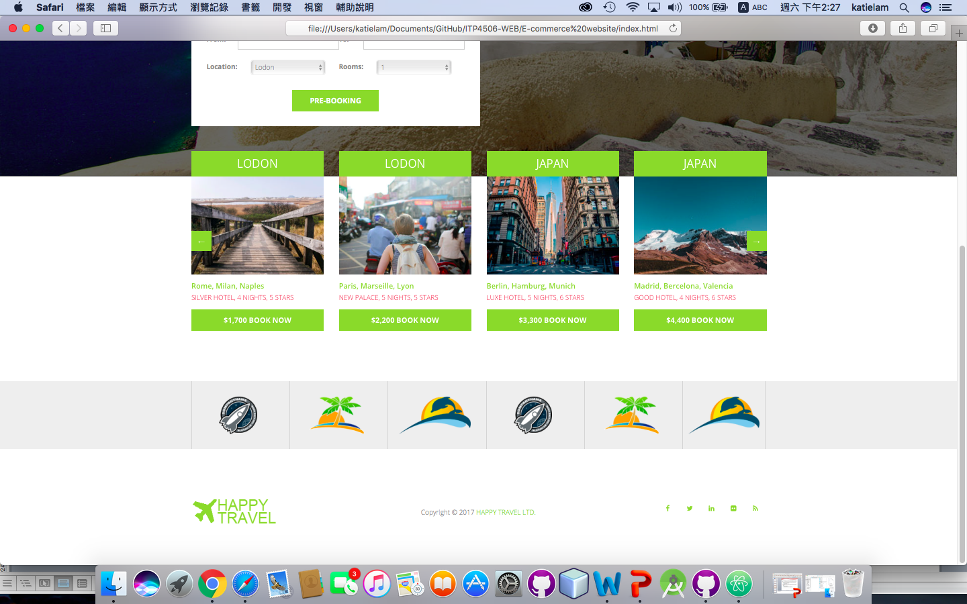

### 3.1.2. Hotel page

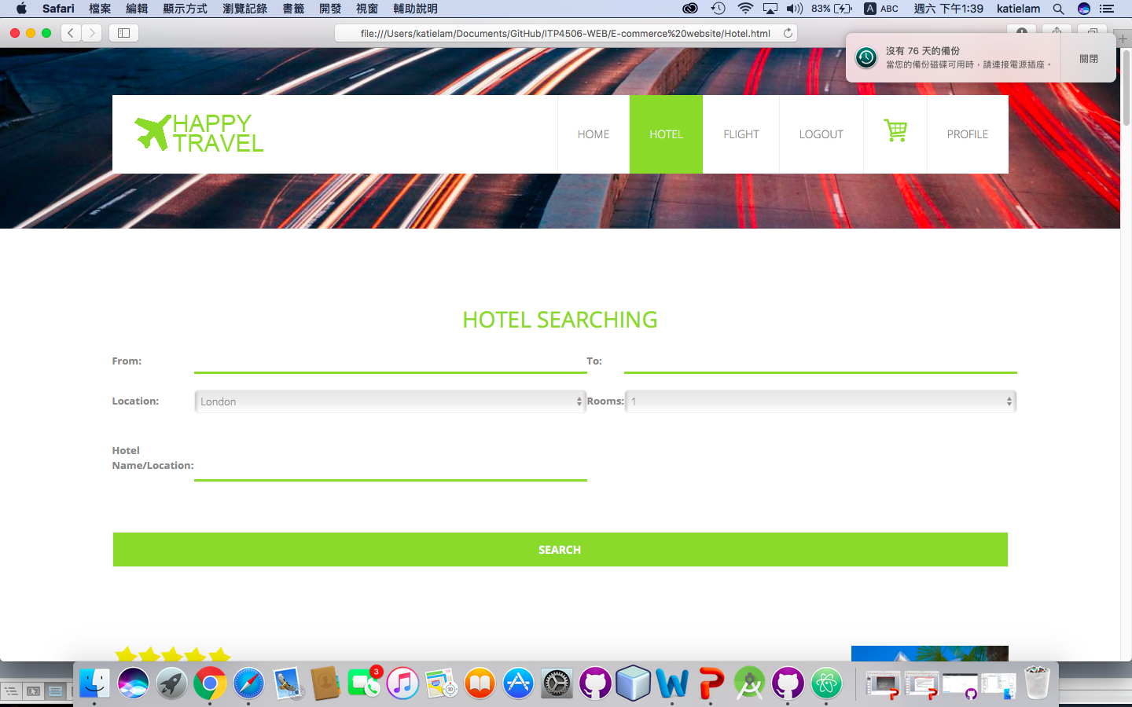

|  |  |
| --- | --- |
| Design Principles | Description |
| Mental Model |  |
| Affordance |  |
| Content Organization |  |
| Visual Organization |  |
| Navigation |  |

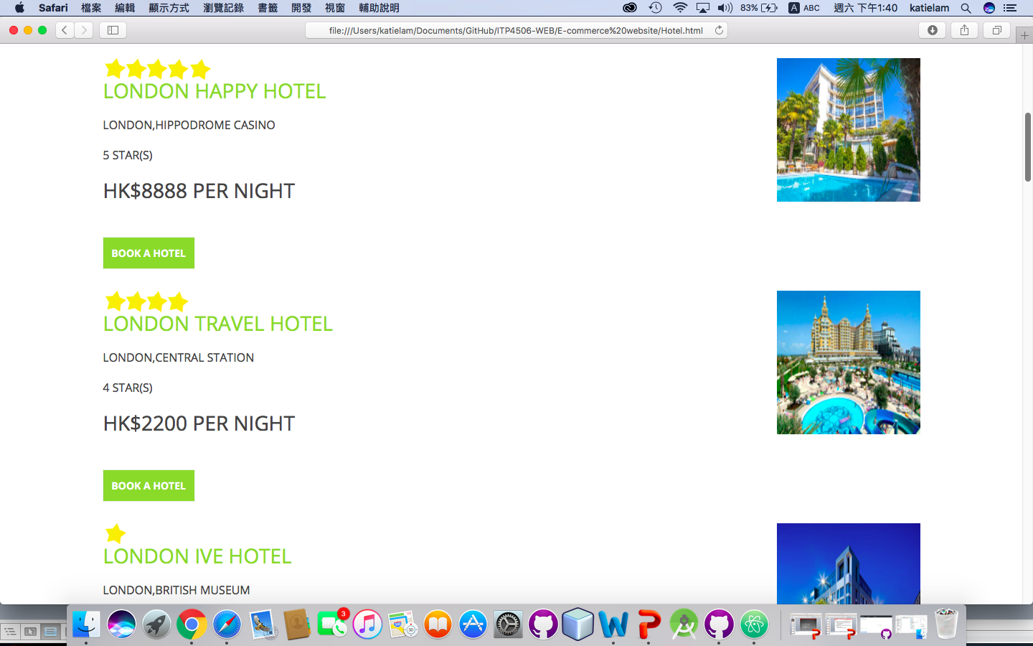

### 3.1.3. Flight page

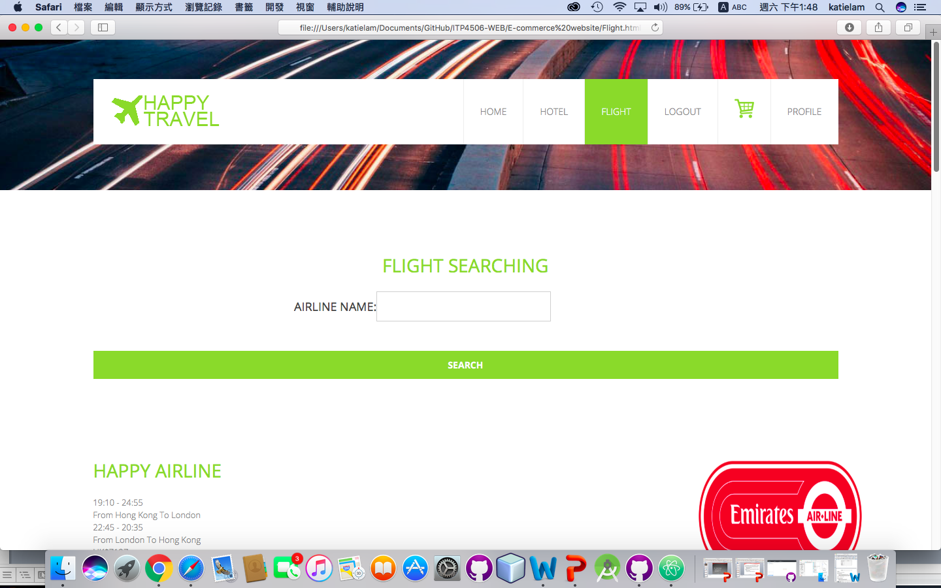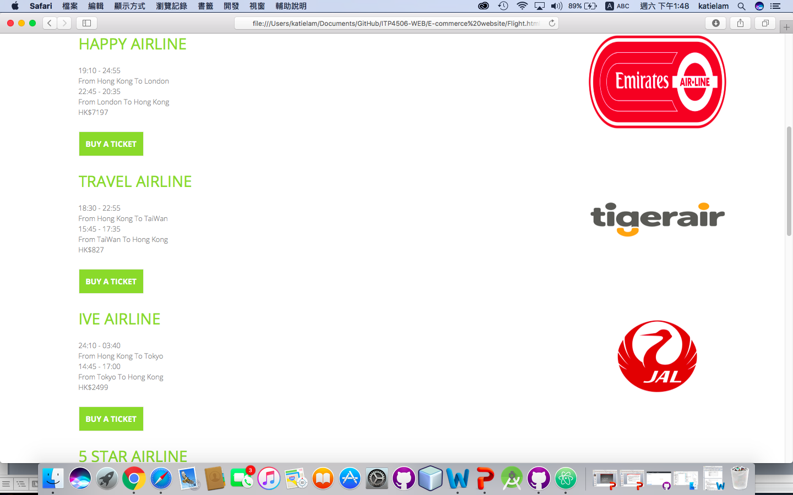

|  |  |
| --- | --- |
| Design Principles | Description |
| Mental Model |  |
| Affordance |  |
| Content Organization |  |
| Visual Organization |  |
| Navigation |  |

### 3.1.4. Register/Login Page

|  |  |
| --- | --- |
| Design Principles | Description |
| Mental Model |  |
| Affordance |  |
| Content Organization |  |
| Visual Organization |  |
| Navigation |  |

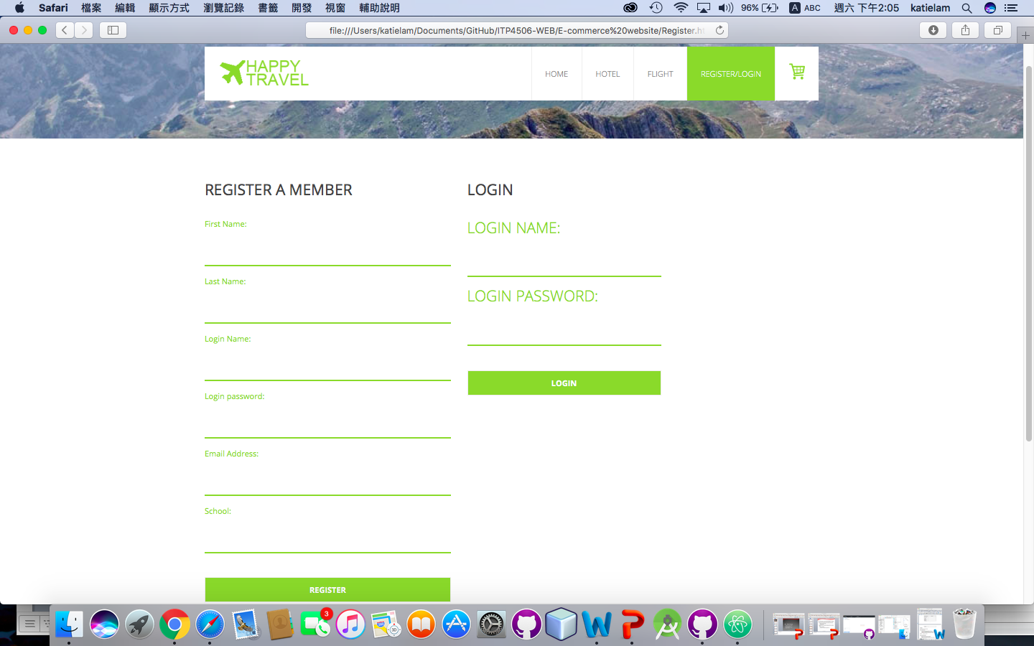

### 3.1.5. Shopping cart Page

### 3.1.6. Payment Page

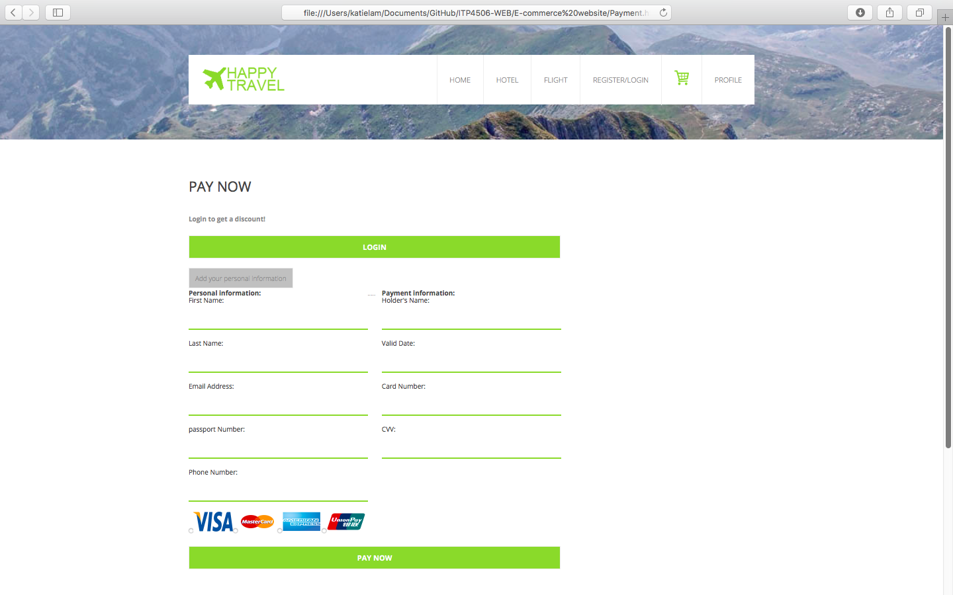

|  |  |
| --- | --- |
| Design Principles | Description |
| Mental Model |  |
| Affordance |  |
| Content Organization |  |
| Visual Organization |  |
| Navigation |  |

### 3.1.7. Profile Page